John Christman

IST 659 Section 402

Mariner Match

Table of Contents

**Table of tables** 2

**Table of Figures** 3

**History of Mariner Match** 4

**Application Concept** 4

**Use Cases** 5

**Attributes and Relationship table** 6

Table 1 Entity Relationships 7

**Logical Normalized Model** 7

**Execution** 8

**Assumptions** 8

**Conclusion** 8

**Appendices** 9

**Data** 9

Table 2 – Mariner sample data 9

Table 3 – Boat sample data 9

Table 4 – Dock sample data 9

Table 5 – Job sample data 10

Table 6 – Skill sample data 10

Table 7 – Location sample data 10

**Glossary (data dictionary)** 11

References 19

## **Table of tables**

Table 1 Entity Relationships 7

Table 2 – Mariner sample data 9

Table 3 – Boat sample data 9

Table 4 – Dock sample data 9

Table 5 – Job sample data 10

Table 6 – Skill sample data 10

Table 7 – Location sample data 10

## **Table of Figures**

Figure 1 – Normalized Logical Model 7

Figure 2 - Display the boats, owner names, locations, and count of jobs by city 14

Figure 3 - a view of all jobs in a dock 14

Figure 4 – All boats with their dock and location 15

Figure 5 - mariners in location by skill by years of experience then location 15

Figure 6 – Mariner entry form 16

Figure 7 – Mariner entry form with location expanded 17

Figure 8 – Boat Job Report 18

## **History of Mariner Match**

There is an old adage that says, “The happiest days of a boat owner’s life are the day they buy their boat and the day they sell it.“ The sentiment, while tongue in cheek accurately captures the truth that owning a boat involves work. Furthermore, that work is often challenging, expensive and occurring at the worst possible moment. Despite all of this boat sales continue to rise with “approximately 276,000 new power boats sold in 2018, continuing an 8-year trend of growth”. In addition, “there were an estimated 988,200 pre-owned boats (powerboats, personal watercraft, and sailboats) sold in 2017, the highest pre-owned boat unit sales since 2006, totaling $9.3 billion in sales, an increase of two percent from 2016.” (https://www.nmma.org/statistics/article/21974, 2018).All told, there are over 12 million registered boats in the US as of 2016. These numbers don’t include the marinas that support the boat owners. All this leads to a large group of boat owners with a need for help. Another often quoted sentiment is “the best type of boat is the kind you get invited on”. There are plenty of non-boat owners with skills ranging from the motivation to lend a helping hand to highly qualified captains and engineers that would be happy to provide services in exchange for the opportunity to spend time on and with boats. Furthermore, many professional certifications require time at sea which is difficult to obtain if you do not own a boat. Today’s trend toward the “gig economy” matches this concept of short term, as needed work. It affords a mariner the opportunity to work as needed and then return to cruising when the season or opportunity presents itself. Conversely, presenting talent and competition to boat and marina owners allows them to evaluate and choose the personnel solution that is best for their situation.

## **Application Concept**

Mariner Match is a theoretical application that would map boat and marina owners with job needs to people with the skills and a desire to work in the area needed. Stakeholders involved include individual workers with skills and/or a desire to work in the marine industry as well as boat and marina owners with job needs. An industry proven opportunity for application revenue exists. Utilizing Google Sense with an average cost per click (CPC) of $0.25 would generate $100,000 per year given 1,000 clicks per day (Mohan, 2018). CPC can be driven higher with advertisement customized to location, boat types and job type. Development, maintenance and hosting costs would be off-set by the advertisement revenue. Currently established companies that perform marine work would potentially be impacted by the exposure of new a workforce, however, there would be no restrictions on employers joining Mariner Match. Workers would be able to see boats and marinas with locations and jobs that match their desires and qualifications. A side benefit for workers would be the ability to see what jobs are needed in a geographic area. This would help shape their pursuit of future education or certifications to address the demands of the marketplace. The result would be a win-win for boat, marina owners and workers. The initial design effort will focus on the database that will serve as a backend to the web application.

Mariners are described with a name, address, experience and skills. Boats are described by Name, type, power, location, and available jobs. Available jobs have a description, the skills required and the duration. Marinas are described by their name, location and available jobs. Finally, skills have a name and the years of experience. Boats are linked to one mariner as the owner and one marina only. This ties to boat to a person with the job and a location for the work to be performed. Mariners are linked to one or more skills that would be needed for a job. A mariner could be any combination of a boat owner, a marina owner or a worker.

The Mariner Match has a database structure that accepts data from boat owners, marina owners and individuals to build a repository of available maritime jobs and people available to perform the work that can be matched by the skills required. Design and testing will conform to agile methodology with a goal of delivering an initial product in two months and the full production database at the end of 90 days. The database was introduced at the Newport boat show with developers collecting and inputs the initial data sets. The full product including the application front end is targeted for a soft launch at US boat shows beginning in October. The primary risk to the proposed solution would a lack of user data, however initial response was strong. If users are uninterested or unwilling to enter their job and/or skills data, then the system will not yield enough matches. Appropriate legal reviews continue to be necessary to ensure the system is removed from any culpability should an owner hire an unqualified person.

## **Use Cases**

Mariner match is intended to serve as a central repository for maritime related work and mariners looking for work opportunities. Mariners can be both owners (boat or dock) and workers, but it is not required. Every mariner would have a base skill of laborer with additional skills added by the mariner as appropriate. Boat owners would assign their boat to a dock as a way of providing a location. Owners would create as many jobs as necessary that would be searchable by mariners looking for work opportunities. Once the database is sufficiently populated, the system should be able to return answers similar to the following:

* + How many boats need captains at my location
  + What are the names of the mariners looking for engine work at my location
  + Show me all of the jobs that only need a basic laborer skill

Outside of the application scope

* + What are the skills required by law to pilot a commercial vessel
  + What are all the maritime jobs in Ft Lauderdale, FL (Job data is only based on what is entered, not every job available)
  + What jobs are available at the Annapolis boat show (There isn’t support for maritime related events such as boat shows)

## **Attributes and Relationship table**

## 

|  |  |
| --- | --- |
| Entity | Attribute |
| Mariner | Name(rc)  Address (rc)  Phone Number  Email Address (r)  location (r)  skills |
| Boat | Name (r)  Owner Name (rc)  Type  Power (r)  dock (r)  pier  slip  Jobs (m) |
| Dock | Name (r)  Phone Number (r)  Jobs (m)  location (r) |
| Skill | Name (ru)  Years of Experience (r) |
| Jobs | Description (r)  Skills Required (r)  Duration  Compensation |
| Location | Street Address (r)  City (r)  State_prov(r)  postal_code(r) |
| Relationships | |
| A Mariner owns zero or more Boats, A Boat is owned by only one Mariner  A Mariner has one or more skills, Skills can be assigned to one or more Mariners  A Boat can have zero or more Jobs, Each Job is assigned to zero or more boats  A Boat is located in only one Marina, Marinas can have zero or more boats  A Marina can have zero or more Jobs, Each Job is assigned to zero or more Marinas  Skills are required for zero or more Jobs, Jobs need one or more Skills  Mariners have one location, A location can be assigned to or more Mariners  A Dock has one location, A location is be assigned to one dock | |

### Table 1 Entity Relationships

## **Logical Normalized Model**

During the transition to the logical model, the design team determined a change was needed to the Marinas entity to add detail and to reduce the chance for error in confusing Mariner with Marina. As a result, the entity name was changed from “Marina” to “Dock”. Additional attributes specify the pier and slip number. For boats that are moored to a private dock, this will be entered as P1, S1. All commercial marinas will specify the name, pier and slip number of the boat.

Marine industry certifications are based on whole years of experience. Accordingly, the attribute is limited to integers and will be entered in the database in total months. Compensation can be either monetary or non-monetary such as room and board.

A location entity has been added as it is common to both docks and mariners

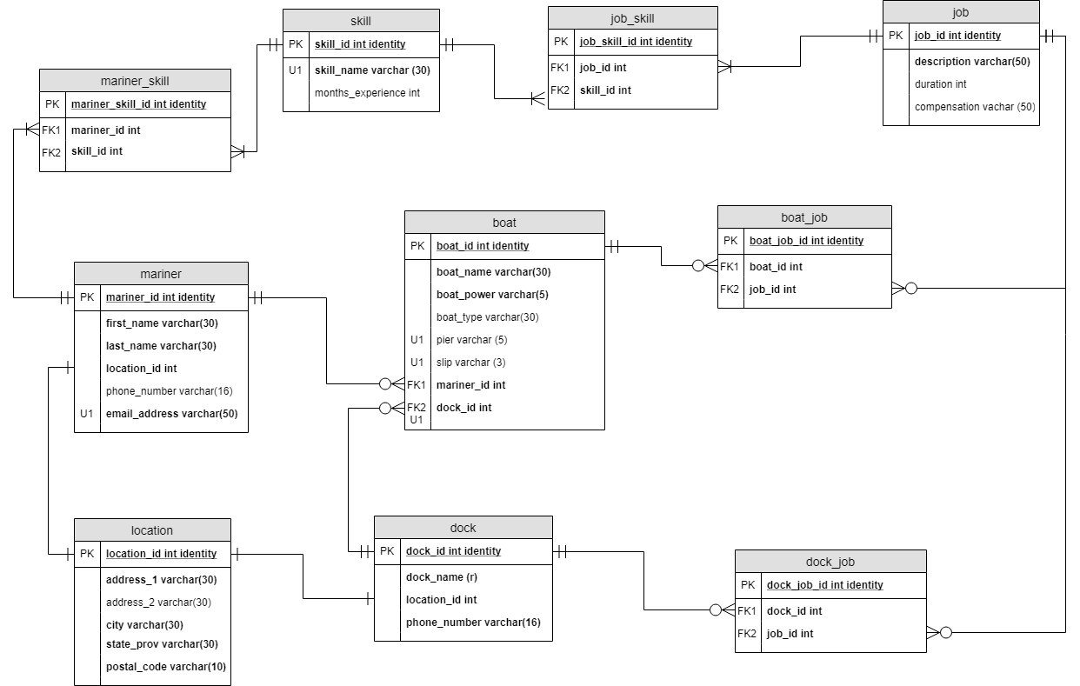

Figure 1 – Normalized Logical Model

## **Execution**

The database has been completed along with a front-end MS Access® form for entry of the mariner data and their skills. The design team elected to focus on this data after determining that mariner and skill data was most critical to the project success. A report of all boats and their jobs was also developed to encourage membership by providing a view into the opportunities available to mariners for work. Results of several data queries, the form and report, are included in the Appendices for reference. Despite the enthusiastic response during the soft opening, the database size remains relatively modest. The developers recognize that additional performance tuning may be required as the database grows. For example, the boat power field has been targeted for conversion from a varchar to a simple char.

## **Assumptions**

The application interface will be responsible for enforcing data entry constraints. For the skill set entries, a drop-down list will pre-populate with the existing skills list with an option for the user to enter a new skill if it does not currently exist in the database. Additionally, the designers recognize that capturing additional contact data for both mariners and docks may be beneficial for future interactions. The system is not intended to validate the skills claimed by mariner. The option to add certification or license information would also be considered for future versions.

## **Conclusion**

Mariner Match brings the gig economy model to the maritime service industry with additional benefits to both owners and workers. The database captures, stores and provides reporting of available jobs classified by boat type, job type, location and required skills. Additionally, individuals desiring work can provide their location and skills sets. A front-end application is still required provide both a portal to view the information from either perspective as well as a match capability for owners with jobs and workers with the corresponding skills. The consolidation of available talent will increase price competition providing value to owners. The consolidation of available jobs allows workers to pursue the opportunities when and where they desire, identify market needs and gain the experience required to achieve higher-level skills. Bringing together both groups provides a strong revenue opportunity for businesses to deliver targeted advertising based on jobs, boats types and even lodging and food for workers that may be traveling for work. Based on similar products this cost model would deliver revenue that would exceed the operating costs of hosting, the database and application development.

## **Appendices**

## **Data**

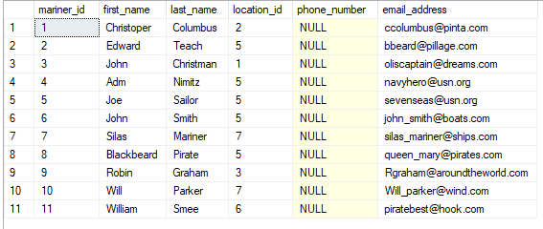

### Table 2 – Mariner sample data

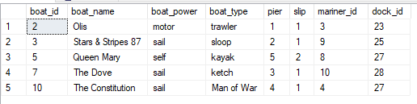

### Table 3 – Boat sample data

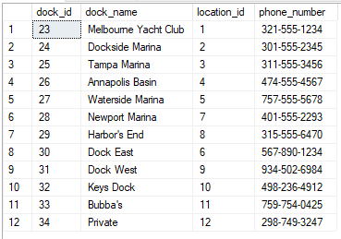

### Table 4 – Dock sample data

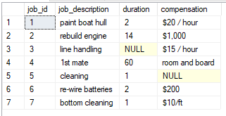

### Table 5 – Job sample data

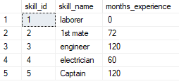

### Table 6 – Skill sample data

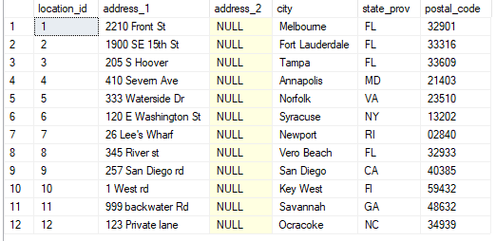

### Table 7 – Location sample data

## **Glossary (data dictionary)**

|  |  |  |  |  |  |  |
| --- | --- | --- | --- | --- | --- | --- |
| **Table** | **P/F** | **Field Name** | **Description** | **Data Type** | **Field Size** | **Notes** |
| location | P | location_id | Locations table primary key | int | identity | R |
| location |  | address_1 | street address | varchar | 30 | R |
| location |  | address_2 | supplementary street address information | varchar | 30 |  |
| location |  | city | city name | varchar | 30 | R |
| location |  | state_prov | state or providence | varchar | 30 | R |
| location |  | postal_code | zip/location identifier | varchar | 30 | R |
| mariner | P | mariner_id | Mariner table primary key | Int | identity | R |
| mariner |  | first_name | Mariner first name | Varchar | 30 | R |
| mariner |  | last_name | Mariner last name | Varchar | 30 | R |
| mariner | F | location_id | location table primary key | int |  | R |
| mariner |  | phone_number | Mariner phone number | Varchar | 16 |  |
| mariner |  | email_address | Mariner email address | Varchar | 50 | R,U |
| boat | P | boat_id | boat table primary key | int | identity | R |
| boat |  | boat_name | name of the boat | Varchar | 30 | R |
| boat |  | boat_power | sail, motor, or self | Varchar | 5 | R – the prime mover of the boat |
| boat |  | boat_type | the class of the boat | Varchar | 30 | sloop, trawler, canoe etc |
| boat |  | pier | the pier where the boat is docked | Varchar | 5 | U must be unique when combined with the slip and the dock name. Equal to 1 for private docks. Default to 1 |
| boat |  | slip | the slip name or number where the boat is docked | Varchar | 3 | U must be unique when combined with the pier and the dock name. Equal to 1 for private docks. Default to 1 |
| boat | F | mariner_id | foreign key linking the boat owner to the boat | int |  |  |
| boat | F | dock_id | foreign key linking the boat to its dock | int |  |  |
| dock | P | dock_id | dock primary key | int | identity |  |
| dock |  | dock_name | The name of the dock | varchar | 30 | R |
| dock | F | location_id | location table primary key | int |  | R |
| dock |  | phone_number | dock phone number | Varchar | 16 | R |
| job | P | job_id | job table primary key | int | identity | R |
| job |  | description | summary of the work to be performed | Varchar | 50 | R |
| job |  | duration | length in days of the work | int |  |  |
| job |  | compensation | summary of the type and amount of compensation | Varchar | 50 | could be monetary, room and board, none etc |
| skill | P | skill_id | skill table primary key | int | identity | R |
| skill |  | skill_name | the name of the skill | varchar | 30 | U, pre-populated with the ability to add |
| skill |  | months_experience | the months of experience for the skill | int |  |  |
| mariner_skill | P | mariner_skill_id | primary key for the table | int | identity | R, links mariniers to their skills |
| mariner_skill | F | mariner_id | foreign key to mariner table | int |  | R, link to mariner table |
| mariner_skill | F | skill_id | foreign key to skill table | int |  | R, link to skill table |
| job_skill | P | job_skill_id | primary key for the table | int | identity | R, links jobs with the required skills |
| job_skill | F | job_id | foreign key to job table | int |  | R, link to job table |
| job_skill | F | skill_id | foreign key to skill table | int |  | R, link to skill table |
| boat_job | P | boat_job_id | primary key for the table | int | identity | R, links boats to their jobs |
| boat_job | F | boat_id | foreign key to boat table | int |  | R, link to boat table |
| boat_job | F | job_id | foreign key to job table | int |  | R, link to job table |
| dock_job | P | dock_job_id | primary key for the table | int | identity | R, links docks to their jobs |
| dock_job | F | dock_id | foreign key to dock table | int |  | R, link to dock table |
| dock_job | F | job_id | foreign key to job table | int |  | R, link to job table |

**Query results**

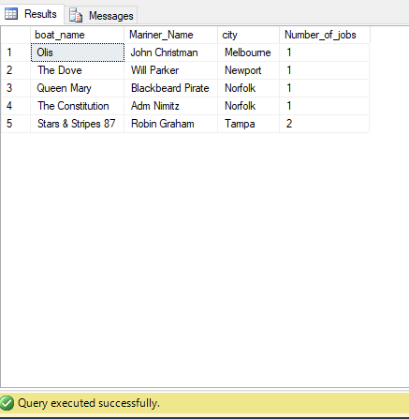

Figure 2 - Display the boats, owner names, locations, and count of jobs by city

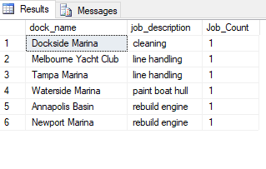

Figure 3 - a view of all jobs in a dock

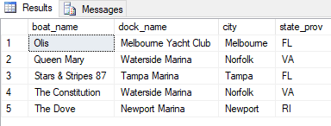

Figure 4 – All boats with their dock and location

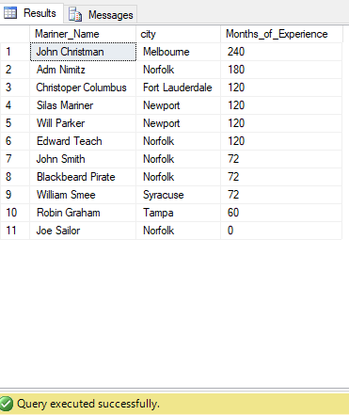

Figure 5 - mariners in location by skill by years of experience then location

**Mariner – Skills Entry Form**

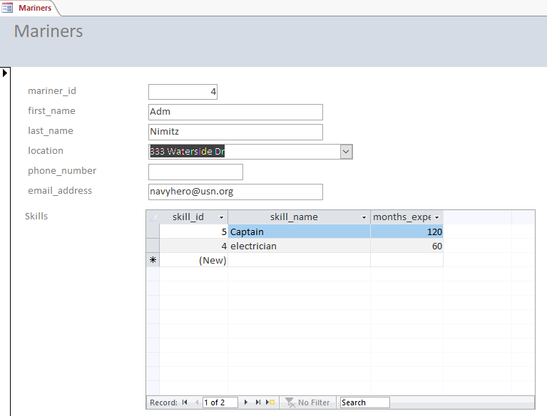

Figure 6 – Mariner entry form

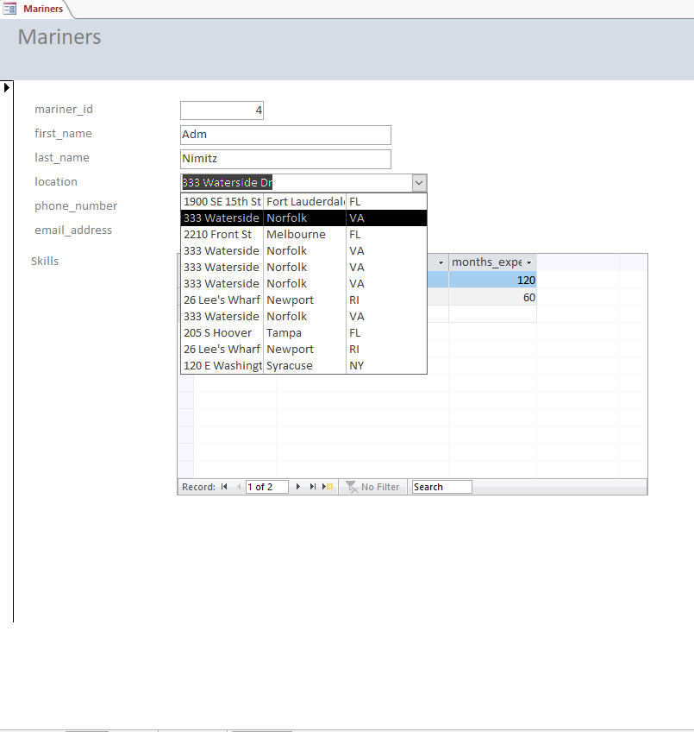

Figure 7 – Mariner entry form with location expanded

**Boat Job Report**

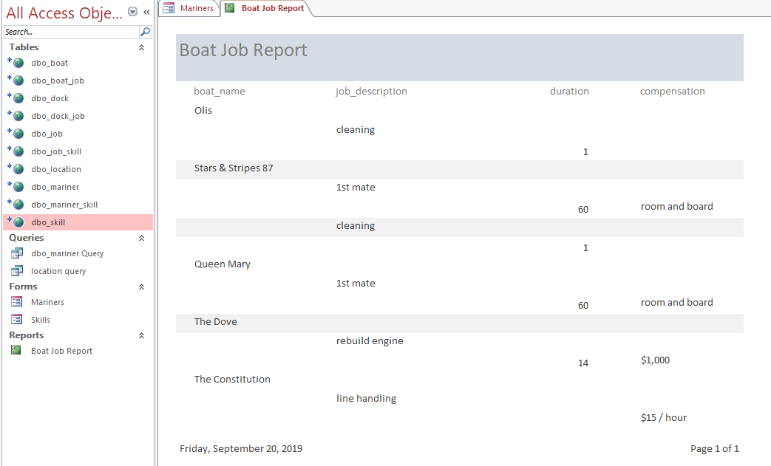

Figure 8 – Boat Job Report

# References

Mohan, M. (2018, January 31). *How Much Traffic Do You Need To Make $100,000 With Google AdSense* . Retrieved from Minterest.com: https://www.minterest.com/how-much-traffic-do-you-need-to-make-money/

*U.S. Boating Industry Sales at a 10-Year High*. (2018, 5 23). Retrieved from National Marine Manufacturers Association: https://www.nmma.org/statistics/article/21974